|  |  |
| --- | --- |
| Name: | Bodhisatya Ghosh |
| Class: | CSE DS |
| Batch: | B |
| UID: | 2021700026 |
| Experiment: | 2 |

**Aim:** Creating static/dynamic link library

**Static linking**

**Code:**

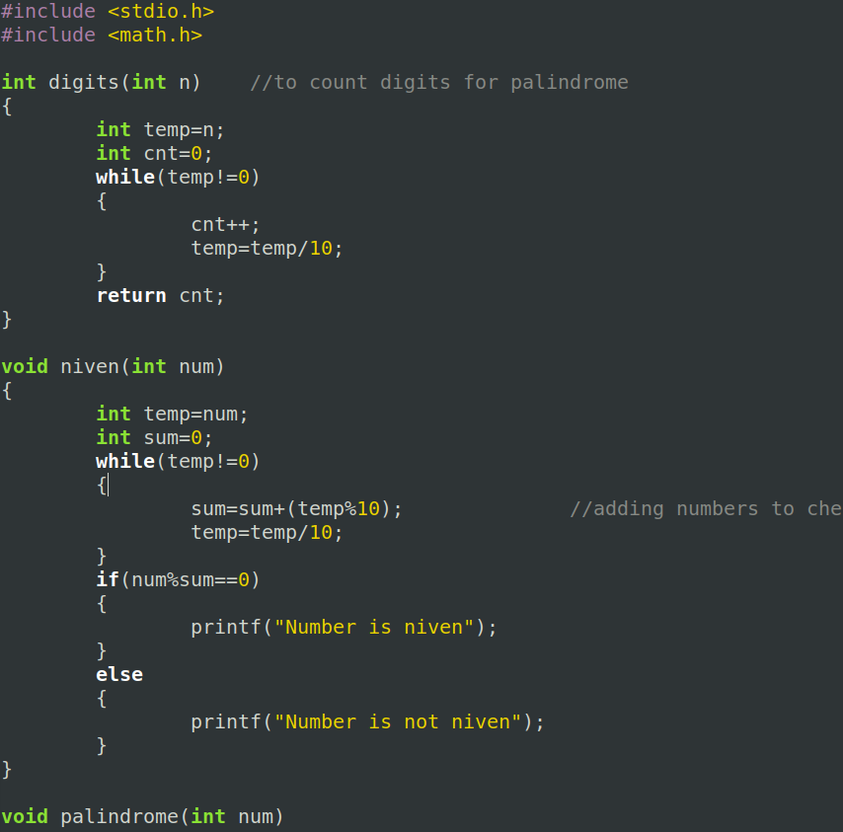

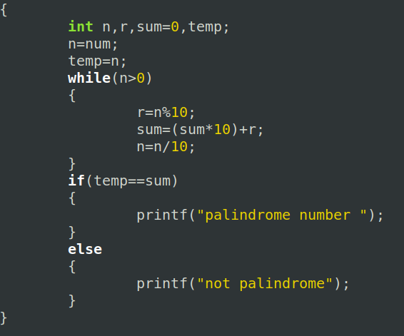

**Static linking**

**Compile code and create a static library of it**

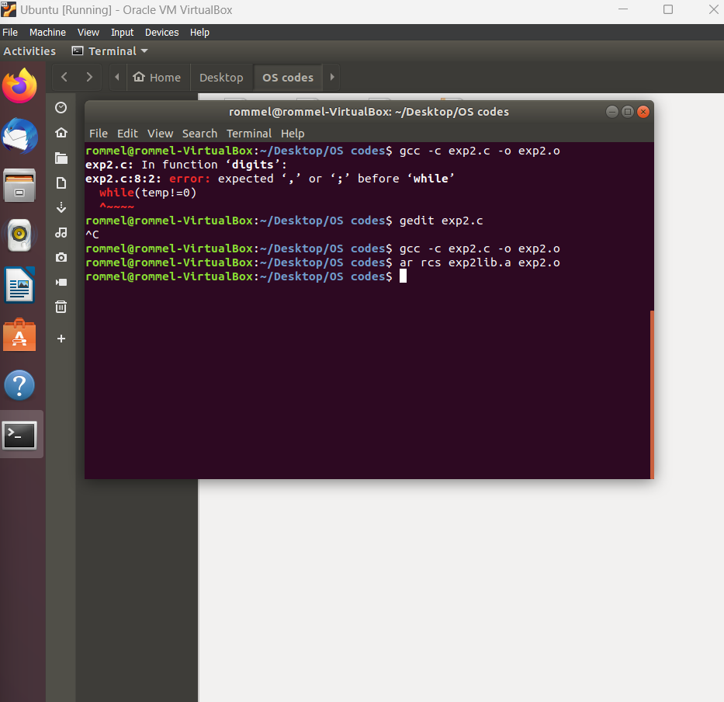

**Create driver program  
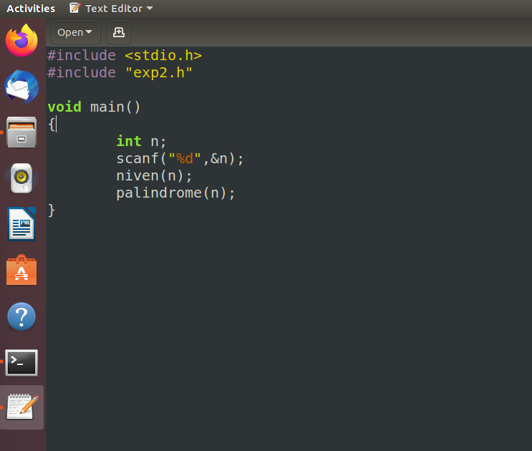**

**Compile driver code and link driver code to custom header file**

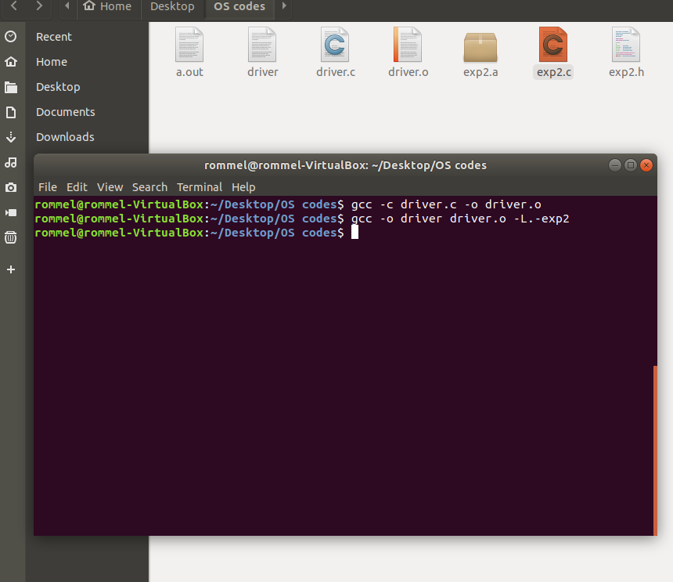

**Execute driver program**

**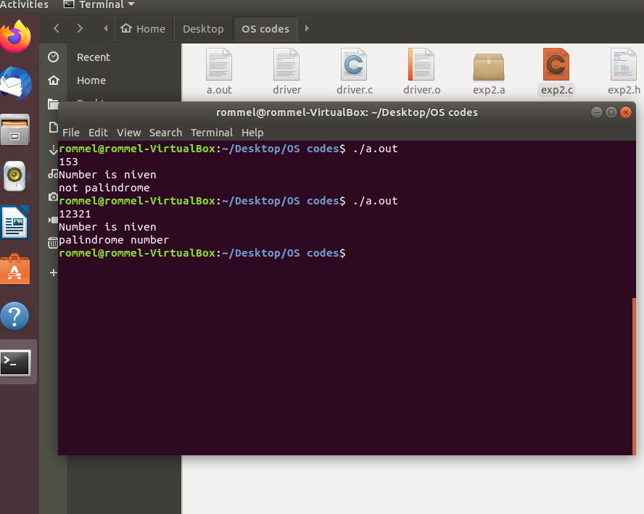  
  
--------------------------------------------------------------------------------------------**

**Dynamic linking**

**Create dynamic library**

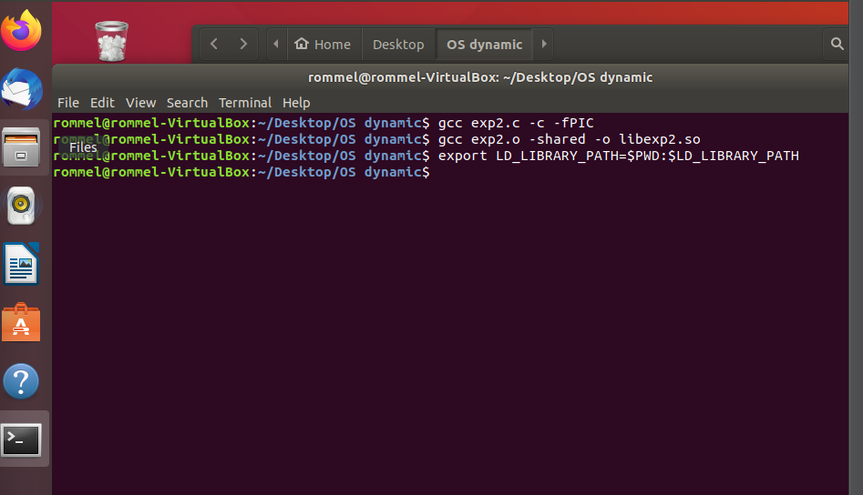**Use dynamic library  
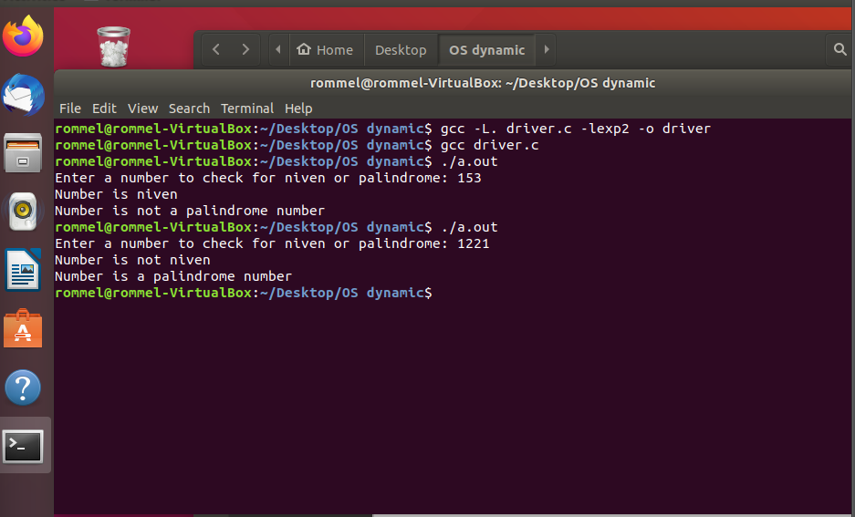  
  
--------------------------------------------------------------------------------------------**

**Conclusion:** In this experiment , static and dynamic linking has been learnt. Functions have been compiled and made into libraries to be used in other codes.